Elementary Peer to Peer Support Template
______ Grade
Description of Student with ASD’s Current Program:

Student with ASD:
Grade:
General Education Teacher:
Special Education Teacher:
Physical Education Teacher:
Art Teacher:
Music Teacher:

Student’s Typical Daily Schedule
Activity | Time | Location | Current Support
Parapro
SpEd Teacher
GenEd Teacher
_________ (other)
Parapro
SpEd Teacher
GenEd Teacher
_________ (other)
Parapro
SpEd Teacher
GenEd Teacher
_________ (other)
Parapro
SpEd Teacher
GenEd Teacher
_________ (other)
Parapro
SpEd Teacher
GenEd Teacher
_________ (other)
Parapro
SpEd Teacher
GenEd Teacher
_________ (other)

Determine where Peer to Peer Supports Can Be Utilized in Student with ASD Schedule
Activity | Time | Location | Peer to Peer Support

Which general education classrooms are selected to recruit same and cross aged peer to peer supports for the student with ASD?
Teacher names
1st Grade | 2nd Grade | 3rd Grade | 4th Grade | 5th Grade

Provide Sensitivity Awareness Training to the Classes Selected (SEE APPENDIX 1). Provide LINK Brochure to inform parents and obtain permission. (SEE APPENDIX 2)

Once the permission slips are collected for peer to peer supports who attend the building the student with ASD attends, determine the number of peer to peer support students from each class.
The team developing the peer to peer support program for the student with ASD must meet with the general education teachers and decide which class can provide support at the time the student with ASD needs peer to peer support. Determine which days and times each general education teacher is willing to have peer to peer support students leave their regular classroom activities to support the student with ASD.

Activity | Day | Time | Peer to Peer Support Class – Teacher’s Name | # of Peer to Peer Support Students

Cross Age Peer to Peer Supports are going to be recruited from:
The Middle School: Yes No
The High School: Yes No
Alternative High School: Yes No
If you are recruiting middle or high school students or alternative high school peers, you must provide Sensitivity Awareness Training to the Cross age Peer to Peer Supports from Middle and High School or Alternative High School. Provide Brochure SEE APPENDIX 3 SPARTAN CREW (Peer to Peer) Secondary to inform parents and obtain permission. SEE APPENDIX 4 FOR AN Example of Sensitivity Awareness Training for Secondary Aged Students.

Once the permission slips are collected for peer to peer support students outside of the building the student with ASD attends, organize the peer to peer support students by class period of attendance.

LINK Name | Time | Middle School | High School | Alternative H.S.

Determine if same age or cross age support will be utilized during the first activity in the student with ASD’s schedule requiring peer to peer support
To keep the scheduling process manageable, the team should schedule the peer to peer support students from the same class for the same activity.

Cross age peer to peer support students in the same building
Once the team determines if there is same or cross aged support, the team selects the class of peers who will support the student with ASD during the time support is needed. The team then develops the schedule of the peer to peer supports including the rotation of peer to peer supports for this activity. The schedule should be posted in the general education classroom where the same age or cross age students attend.

The Team Must Determine if Cross age support from peer to peer support students outside the building, Cross age peer to peer supports from the same building or Same age peer to peer supports at Arrival
Peer to Peer Support at Arrival –
Day of the Week | Go to Lockers | P2P Support Name | Alternate  P2P Name
Monday
Tuesday
Wednesday
Thursday
Friday

The Team Must Determine if Cross age support from peer to peer support students outside the building, Cross age peer to peer supports from the same building or Same age peer to peer supports at Recess
Peer to Peer Support at Recess –
Day of the Week | Go to Lockers | P2P Support Name | Alternate  P2P Name
Monday
Tuesday
Wednesday
Thursday
Friday

The Team Must Determine if Cross age support from peer to peer support students outside the building, Cross age peer to peer supports from the same building or Same age peer to peer supports at Lunch
Peer to Peer Supports at Lunch –
Day of the Week | Go to Lockers | P2P Support Name | Alternate  P2P Name
Monday
Tuesday
Wednesday
Thursday
Friday

The Team Must Determine if Cross age support from peer to peer support students outside the building, Cross age peer to peer supports from the same building or Same age peer to peer supports during Reading Buddies
Peer to Peer Supports at Reading (Buddies) –
Day of the Week | P2P Support Name | Alternate  P2P Name
Monday
Tuesday
Wednesday
Thursday
Friday

The Team Must Determine if Cross age support from peer to peer support students outside the building, Cross age peer to peer supports from the same building or Same age peer to peer supports at Support (Time During the Day that Students are allowed to work on homework or in class work)
Peer to Peer Supports during Support
Day of the Week | Classwork / Homework | P2P Support Name | Alternate  P2P Name
Monday
Tuesday
Wednesday
Thursday
Friday
The Team Must Determine if Cross age support from peer to peer support students outside the building, Cross age peer to peer supports from the same building or Same age peer to peer supports at the Class Meeting.
Peer to Peer Supports at Class Meeting –
Day of the Week | P2P Support Name | Alternate P2P Name
Monday
Tuesday
Wednesday
Thursday
Friday

The Team Must Determine if Cross age support from peer to peer support students outside the building, Cross age peer to peer supports from the same building or Same age peer to peer supports at Departure
Peer to Peer Supports at Departure –
The departure peer is the alternate arrival peer to peer support.
Day of the Week | Go to Locker | P2P Support Name | Alternate  P2P Name
Monday
Tuesday
Wednesday
Thursday
Friday

Student’s General Education Classroom Specials Schedule
Day of the Week | Special | Time
Monday
Monday
Tuesday
Tuesday
Wednesday
Wednesday
Thursday
Thursday
Friday
Friday

The Team Must Determine if Cross age support from peer to peer support students outside the building, Cross age peer to peer supports from the same building or Same age peer to peer supports at Specials
Peer to Peer Support Specials Schedule
Special
Week # | Day of the Week | Alternate
1st Week
2nd Week
3rd Week
4th Week
Changes Needed

The Team Must Determine if Cross age support from peer to peer support students outside the building, Cross age peer to peer supports from the same building or Same age peer to peer supports at Specials
Peer to Peer Support Specials Schedule
Special
Week # | Day of the Week | Alternate
1st Week
2nd Week
3rd Week
4th Week
Changes Needed

The Team Must Determine if Cross age support from peer to peer support students outside the building, Cross age peer to peer supports from the same building or Same age peer to peer supports at Specials
Peer to Peer Support Specials Schedule
Special
Week # | Day of the Week | Alternate
1st Week
2nd Week
3rd Week
4th Week
Changes Needed
Student with ASD Master Schedule for Peer to Peer Supports
Activity | Time | Location | Peer to Peer Support  Same Age/Cross Age

Appendixes

Example of ELEMENTARY Sensitivity Awareness Training

Appendix 1
Sensitivity Training Session #1 – Communication

Age of Students: Preschool through 3rd Grade
Staff needed: A teacher/consultant knowledgeable in autism
General Education Population: Preschool students (3 & 4 yrs old) through 3rd grade. Students who are aware of students with autism in the general education setting.
Materials needed: None
Time Allotment: Approximately 15-20 minutes

Important Issues:
- Obtain permission from the parent of the student with ASD to discuss autism with other students in the class while referring to their child
- It is important to name the student because this allows the students to focus in on the student and not try to guess which student it might be.
- General education students know there is something different about the student with autism. Trying to talk about autism without naming the student just adds to the mystery. Students are much more supportive of a student with autism once they have information about autism.
Important Concepts:
      - An understanding of the unusual stereotypical behaviors of students with autism.
      - An understanding of how difficult it is to communicate without using words.
      - An understanding of the behavior of the students with autism within the classroom.
      - A sense of control for the general education students when they are around students with autism.
Objectives:
      - To give the general education students in the classroom awareness of autism.
      - To provide the general education students an opportunity to develop empathy for students with autism.
      - To allow general education students the opportunity to observe how student behavior changes when communication is impaired.
      - To allow general education students to demonstrate frustration when they are not being understood nonverbally.
Introducing the Activity:
      - General education students in the classroom can either sit at their desk or in a large group setting.
      - The teacher/teacher consultant knowledgeable of autism is introduced to the class.
      - The teacher informs the class he/she is there to help them understand a disability called autism.
      - The teacher then tells the class he/she would like to play a game while he/she is teaching the class about autism.
Sensitivity Training - Activity#1

The teacher explains the rules of the game:
- The students cannot talk or write any information.
- The students must let the teacher know they must use the bathroom and it is an emergency.
- The students must follow the teacher as he/she is speaking.
- The students cannot exit the classroom while the teacher is speaking.
- The students can use any method except talking and writing the information to help the teacher understand the need to use the bathroom.

The teacher begins to explain autism in very simplistic terms:
- You cannot catch autism.
- Autism is something you are born with.
- Autism affects more boys than girls.
- Autism does not have a cure.
- You cannot die from autism.
- Some people with autism communicate in different ways: letter boards, picture boards, sign language, augmentative devices, etc.
- Some people with autism like to do things over and over again because it makes them feel better.

While the teacher is teaching about autism, students are trying to get the teacher’s attention through gestures, movements, noises, pointing, etc. about the need to use the bathroom.

As the students try to gain the attention of the teacher, the teacher is negatively responding to the student behavior:
For example:
“You need to sit down and listen.” “Please don’t disrupt the class”
“Are you sick? Do you need to go to the office?” “Do you need help”
“You are not making any sense” “Why are you acting like that”
“I don’t understand what you need”

As the teacher is teaching, the student’s behavior continues to increase.

The teacher consultant continues to redirect the behavior of the students.

The teacher then tells the group the game is over.

APPENDIX 2
LINK Brochure Elementary

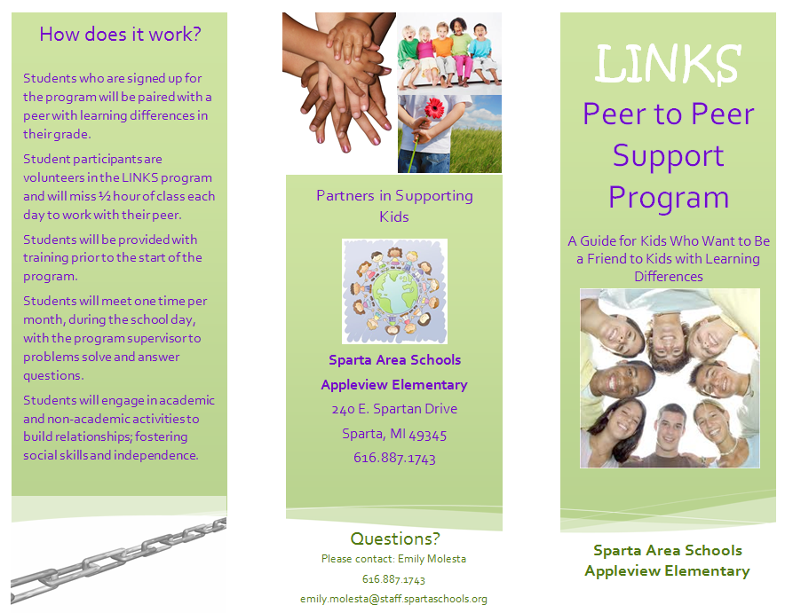
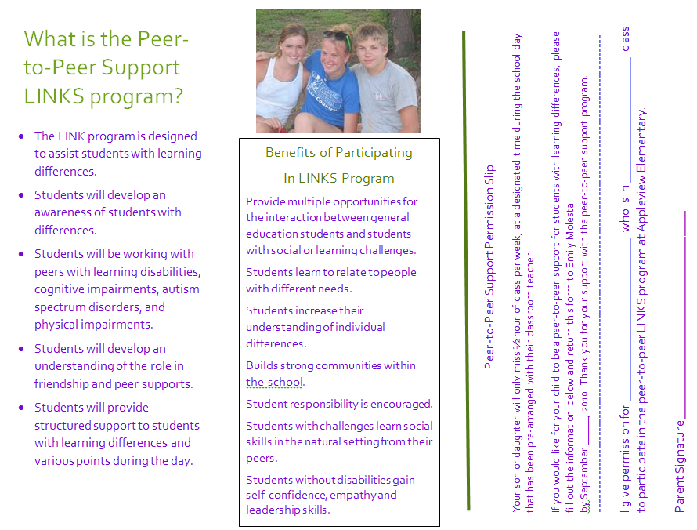
APPENDIX 3

Example of SECONDARY Sensitivity Awareness Training

Martin Jr. / Sr. School ASD Sensitivity Training
*Pass out notecards and masking tape (put on skin for remainder of presentation)

Introduction
- We’re here today to share a little about autism with you. As we talk and discuss autism today, feel free to ask questions or write down questions on the note cards provided for you.

- Autism Spectrum Disorders, or ASD, include autism and Asperger Syndrome. First, tell me what you think you know about autism and/or Aspergers.
  - confirm things they are correct about
  - guide things they aren’t correct about

DEFICIT AREAS | EXAMPLES
Communication Skills | not talking to talking too much, convo boards
Behavior | yelling, running away
Social Skills | touching, socializing being cognitive instead of emotional/natural, theory of mind, not understanding other’s feelings/social cues
Sensory | headphones, Sensory room, hats

- Strengths of students with autism
  - good memory
  - strong knowledge of certain areas
  - like to have fun

- Without giving names, raise your hand if you know someone with autism.

- Having autism or aspergers can make school really difficult for some students. Next, we are going to give you a little simulation of how a spelling test may feel to someone with autism.

http://www.gvsu.edu/autismcenter/start-resources-55.htm (give test; stop after 5 words)

- How did this feel? Tell me what made that spelling test difficult?

- What other parts of a school day do you think would be difficult for someone with autism?
(Lunch Room- smells, Fire Drills, Loud classes, Changes in routines, Communication- social situation, meeting new friends)

- There is a lot that takes place on any given school day that can be really difficult for someone with autism. What are some ways that you could help?
      - Start conversations
      - Include the student
      - Help with social skills
      - Be a friend!

- Introduce CLIPPERS CONNECT program
      - Clippers Connect is a peer to peer support program that is designed to help students with autism.
      - Students, like yourself, will volunteer to be a LINK to someone with autism and help them out throughout the day.

Closing-
Questions (Give notecards with questions to your teacher)

APPENDIX 4 - SPARTAN CREW
