Google Docs is a free online program that allows users to collaborate, create, edit and store documents online with other users. Create documents, spreadsheets and presentations.
In this session we will focus on using the document portion of Google Docs. (These same instructions can apply to the spreadsheet and presentation files as well.)
1. Register for a Google Account
Click here to register for an account or login if you already have one.
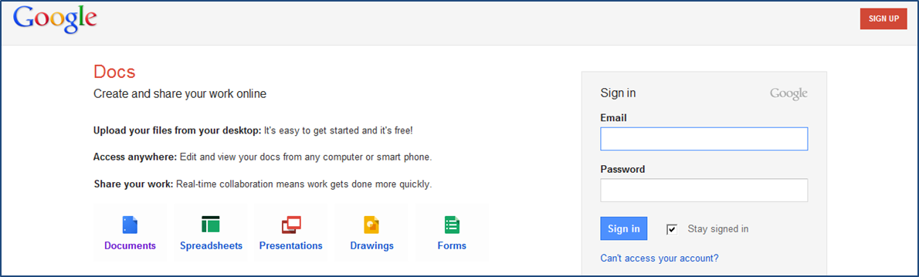
--If you do not have a Gmail account, you can sign up for a free Google account with an email address of your choice and a password. (Note: You must use a real email address because you will be sent an email to confirm your application before completing your Google account.)
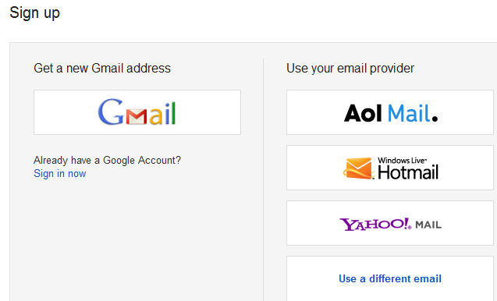
--If you already have a Google account through Gmail then you can use the same login to access Google docs.

Create documents, spreadsheets and presentations online.
No need to save to a local drive—saves to a secure online storage facility; you can access your documents from any computer; option to download a copy

2. Create
You are presented with 2 options:
1) Create basic documents and spreadsheets from scratch
2) Upload existing documents and spreadsheets

3. Edit

Edit with others in real time.
All services have toolbars with all the editing features—easily do all the basics (bold, italics, underline, change font, font color, background color, etc.
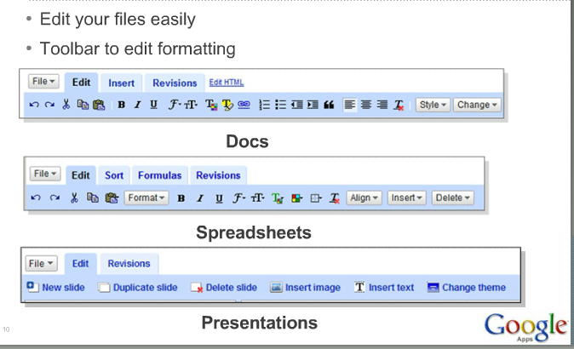

4. Collaborate and Share
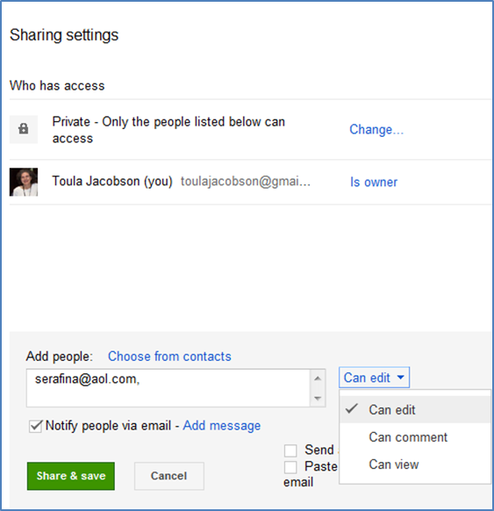
With content online, collaboration is promoted and easy-- any number of users can view and edit at the same time.
-- Share instantly: edit with others in real time by filling out the invitation--add email addresses of those you want to share a given file with.
--Documents can have open or restricted access—users can have access as soon as they sign in
--More than one person can view and make changes at the same time; there is an onscreen chat window
--Document revisions show you who changed what and when
Collaborators have read and edit access
Viewers only have read access

5. Data Storage
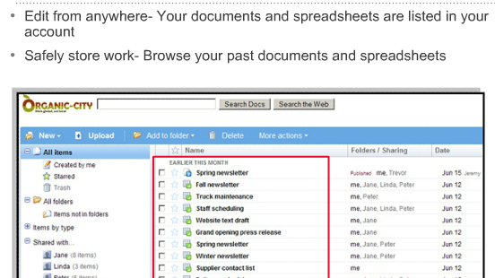
There's nothing to download.
Access your Google docs from any computer with an Internet connection and a standard browser.
All are listed together simplifying browsing and searching for files.
Online storage and auto-save mean you don’t need to fear local hard drive failures and power outages. Save your files to your own computer in DOC, XLS, CSV, ODS, ODF, PDF, RTF and HTML formats.

For more information and help, visit the Docs Help Center and Discussion Group.
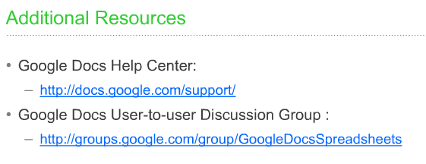
- 21 things for admin page: Collaboration Tools
http://www.21things4administrators.net/collaboration.html

