Picasa and Picasa Web Albums: Control Folders and File Types that Display
You don't need to import photos and videos from a device to Picasa if they are already saved on your computer. Instead, Picasa gives you two tools which let you choose exactly which photos and videos are displayed.
Picasa shows you the photo and video file types that you tell it to find, in the folders that you tell it to search.
Control the folders that display | Control the file types that display
Click Tools > Folder Manager to control which folders are displayed: | Click Tools > Options (PC) or Picasa > Preferences (Mac) to control which file types are displayed
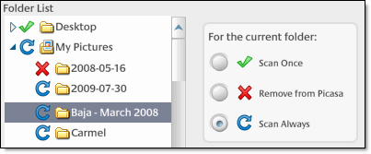 | 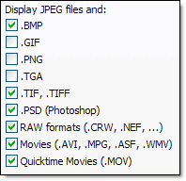

Selecting displayed file types
You have total control over which image file types are displayed in Picasa. To modify which file types are displayed in Picasa, please follow these steps:
- In Picasa, click Tools > Options (Windows) or Picasa > Preferences (Mac).
- Select the File Types tab.
- Select the checkboxes for the file types you want Picasa to detect and display.
- Click OK.

Controlling how folders are monitored
Picasa scans your computer to find folders containing compatible photo file types, and then displays photos from these folders. The photos stay in their original folder locations. You can use the Folder Manager to control the folder locations on your hard drive that the Picasa monitors. Follow these steps:
- Click the Tools menu in Picasa.
- Select Folder Manager.
- Select a folder from the folder list on the left that you want to add or remove from Picasa's watch list.
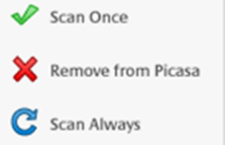
- Select one of the following monitoring options on the right:
  - 'Scan Once': Picasa accesses all compatible image types in these folders only once.
It doesn't detect new photos added to folders with this setting.
  - 'Remove from Picasa': Picasa doesn't look in folders that are marked with this status.
  - 'Scan Always': Picasa views all compatible image types in these folders, and it automatically
adds new photos. Picasa actively scans this folder for changes.
- Click the OK button to save your changes.
The folders that you've set Picasa to continuously scan are listed in the 'Watched Folders' section.

