http://doodle.com/
‘About’ at bottom of page
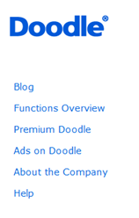

Functions Overview

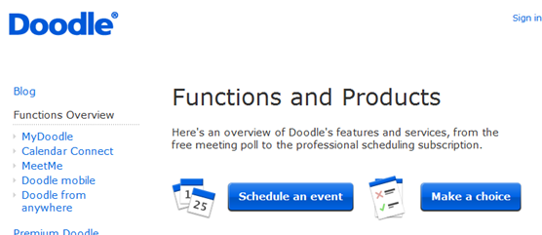
Schedule an Event
or
Make a Choice
No need to add your email!

