iPad2 – Review of Basic Tasks

**Getting Started**

1) **Video**: Take a guided video tour of several iPad 2 programs (Safari, iBooks, Photos)

<http://www.apple.com/ipad/videos/>

2) **User Guide—from the Apple site**  
<http://manuals.info.apple.com/en_US/ipad_user_guide.pdf>

3) **User Guide—from your Bookmark in Safari**

From Safari: Launch your Safari browser from your iPad 2 Tablet, tap on “**Bookmarks**”, there is a link “**iPad User Guide**“, Tap on it, it will take you to the **iPad 2 User Guide**.

4) **Care of your iPad**

How to clean the Touch Screen

To clean iPad, unplug all cables and turn off iPad (press and hold the Sleep/ Wake button, then slide the onscreen slider). **Use a soft, slightly damp, lint-free cloth**.   
*Avoid getting moisture in openings. Don’t use window cleaners, household cleaners, aerosol sprays, solvents, alcohol, ammonia, or abrasives to clean iPad.* The iPad screen has an oleophobic coating; **simply wipe the screen with a soft, lint-free cloth to remove oil left by your hands.** The ability of this coating to repel oil will diminish over time with normal usage, and rubbing the screen with an abrasive material will further diminish its effect and may scratch your screen.

Handle iPad with care to maintain its appearance. If you’re concerned about scratching or abrasion of the screen, you can use the provided screen cover.

5) **Charging the Battery**

iPad has an internal lithium ion rechargeable battery. The battery isn’t user accessible. The battery icon in the upper-right corner of the status bar shows the battery level or charging status. To charge iPad, connect it to a power outlet using the included **Dock Connector to USB Cable** and **10W USB Power Adapter**.

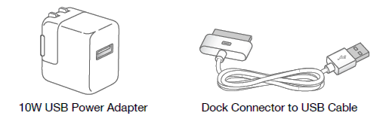

**Apple ID account on your iPad**

An Apple ID is composed of two parts: username or Apple ID and password.

|  |  |
| --- | --- |
| Apple ID (username) |  |
| Apple ID Password: |  |

The **Apple ID** is an authentication system that Apple introduced for many of its products.

You will be prompted to type in your password when downloading and updating apps.

**Basic Tasks**

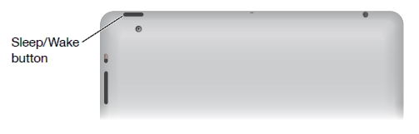

**1)** **Turn iPad on**

Press and hold the **Sleep/Wake button** until the Apple logo appears.

**2) Put iPad in Sleep Mode (option to use slideshow)**

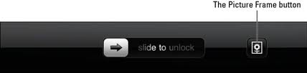Press the On/Off button and let go quickly—this will put the iPad in Sleep Mode.

Click the Picture Frame button to show a slide show.

You can customize this in Settings.

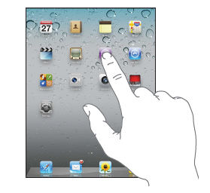**3)** **Opening and Switching apps**

--**Open an app**: Tap its icon on the Home screen.

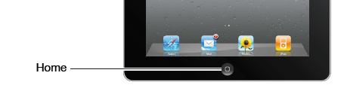

--**Return to the Home screen:** Press the Home button

Multitasking allows certain apps to run in the background, so you can quickly switch between the apps you’re using.

--**View the most recently used apps:**  Access all running apps by **double-clicking** the **Home** button.

The most recently used apps appear in the recents list at the bottom of the screen.   
 Flick left to see more apps.

**To switch to a running app** just tap on it here in this bar.



*This is where you will* ***close*** *an open app*—there is no way to close an app when it is open.

**4)** **Remove *OR* Close an app from the recents list:**

Touch and hold the app icon until it begins to jiggle, then tap 

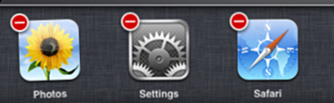 The app is added to the recents list again the next time you open it.

Tap the home screen (or home button) to close the recent apps list.

**5)** **Delete an app from the Home screen:**

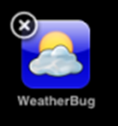Touch and hold the icon of the app you want to delete until it jiggles and an appears.   
(After a few seconds an X will appear next to each of the apps you’ve installed via the App Store.)

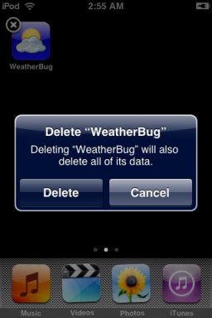Tap the to delete the app. When prompted, select Delete.

You are ***not*** allowed to delete the default applications that came installed on your iPad. These include the Calender, Contacts, iTunes, App Store, Game Center, etc.  
**Important:** Deleting an app from iPad also deletes the documents and data created by the app.

**6) The iPad Included (or Default) Apps**

The iPad comes pre-loaded with a selection of built-in Apple apps. Each of these apps handles a basic task. Unlike any other Apple or third-party apps you may download, **these apps cannot be deleted** from the iPad.

View and read more about these apps in the iPad User Guide: At a Glance > iPad Apps

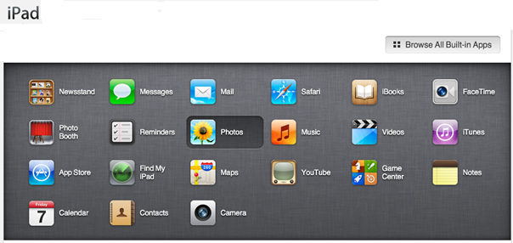

**7)** **Moving and** **Rearranging App Icons**

You can customize the layout of app icons on the Home screen—including the icons in the Dock along the bottom of the screen. If you want, arrange them over multiple Home screens.

**Rearrange icons:**

**1** Touch and hold any icon until the icons jiggle.

**2** Arrange the icons by dragging them.

**3** Press the **Home** **button to save your arrangement**.

**8)** **Organizing with Folders**

Folders let you organize icons on the Home screen. You can put up to 20 icons in a folder. iPad automatically names a folder when you create it, based on the icons you use to create the folder, but you can change the name.

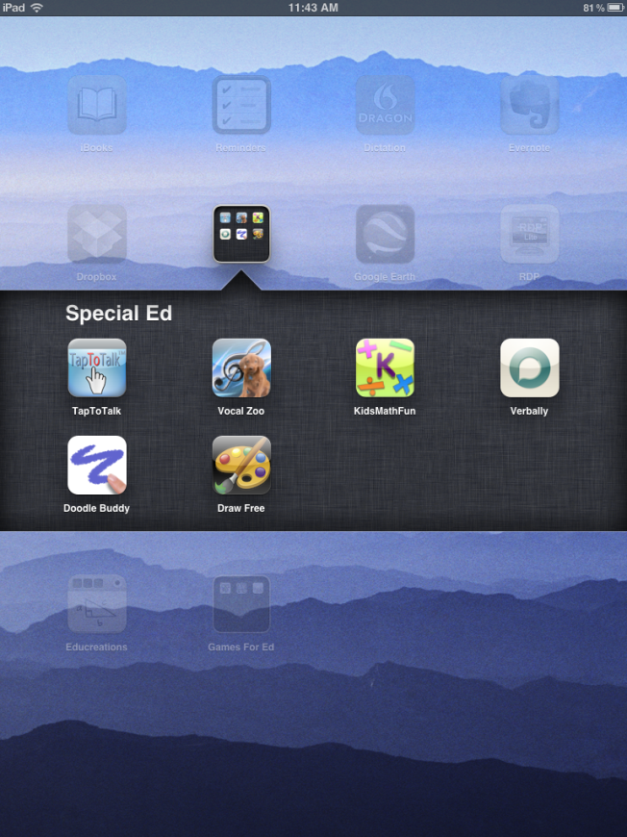

**--To Create a Folder  
Touch and hold an app icon** until they all start to **jiggle***, then drag the app icon over another icon and release.*

**1**  iPad will create a new folder with both apps in it, and shows the folder’s name. The folder will be named according to the category of the apps it contains, but you can rename it as you like.

**2**  Double tap the folder to open it and see its contents.

**3**  Just tap the name field to enter a different name.

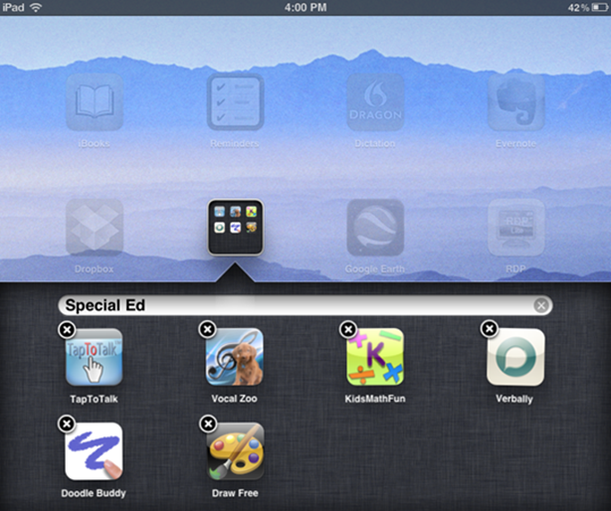

**--To Rename a Folder**

**1** Touch and hold down the folder icon until it begins wriggling.

**2** Tap the wriggling icon to open folder window .

**3**  Tap the name at the top and use the keyboard to enter a new name.

**4**  Press the Home button to stop wriggling and save changes.

**5** Tap the folder to close it.

When you finish organizing your Home screen, press the Home button to save your changes.

**Folder Actions**

|  |  |
| --- | --- |
| **Add an icon to a folder** | While arranging icons, drag the icon onto the folder. |
| **Remove an icon from a folder** | While arranging icons, tap to open the folder, then drag the icon out of the folder. |
| **Open a folder** | Tap the folder. You can then tap an app icon to open that app. |
| **Close a folder** | Tap outside the folder, or press the Home button. |
| **Delete a folder** | Remove all icons from the folder.  The folder is deleted automatically when empty. |
| **Rename a folder** | While arranging icons, tap to open the folder, then tap the name at the top and use the keyboard to enter a new name. Press the Home button to save your changes. |

**9) Hand Gestures and Techniques** for navigating the touch screenIf you've never before owned a multitouch device from Apple, you may be unfamiliar with crazy phrases like *pinch-to-zoom* and the difference between *flick and swipe*. Have no fear: While some of these gestures may have odd names, they're easy enough to pick up.

**--Tap**   
As clicking on a mouse is to a desktop computer, so is tapping to an iOS device. Tapping is the most basic gesture you can do on the iPad. You tap to open apps, bring up controls, acknowledge menus, and more.

**--Double-Tap**   
Tap an object twice in succession to effect a double-tap. Double-taps are primarily used for zooming in or out on text, but third-party apps also use the double-tap to various means.

**--Tap, Hold, and Drag**   
For some functions—such as highlighting text, copying and pasting, or deleting and moving apps—you'll need to tap and hold down on the screen. When you do this on a piece of text, it will highlight in blue, and editing handles—lines with blue dots—will appear on either side. You can tap, hold, and, while holding down, drag your finger to increase or decrease the highlighted area. Dragging also comes into play for moving objects in apps, drawing, and swiping and flicking.

**--Flick and Swipe**   
Drag your finger across the screen—up, down, left or right—to swipe. Swiping is one of the primary navigational tools on the iPad—you use a left or right swipe to get through app pages on your Home screen, or an up or down swipe to read text in Safari—and it's one of the easiest gestures to learn. A flick is just like a swipe, only faster: the iPad supports inertial scrolling, which means that the faster or slower you move your finger, the faster or slower content will move.

One note of caution: All flicking and swiping on your iPad is inverse, meaning that when you move your finger down (in other words, swipe down), you're actually moving whatever is on the screen upward. This makes perfect sense in the real world, but coming from a computer, where scrolling down on a trackpad or mouse actually scrolls the window down, it can be a bit disorienting at first. Why make the clarification? In this book, we refer several times to "swiping right" to bring up a left-hand navigational bar—which can be confusing to parse, if you don't know about inverse gestures.

**--Pinch**   
To zoom in or out, or to open a closed collection of Photos in the Photos app, you'll use the pinch gesture (also sometimes referred to as pinch-to-zoom). To zoom in or to open something, place your thumb and index finger, pinched together, on screen and spread them apart. To zoom out, do the reverse: start with your thumb and index finger spread outward, and then pinch them together.

**--Rotate**   
With two or more fingers, you can even rotate some elements. Just hold two fingers on screen, and make a circular gesture—clockwise or counter-clockwise.

--**4-finger swipe up** (multitouch gesture) -  
Must be turned on in settings  
Left or right 4-finger swipe lets you move between apps you have open  
You may want to set non-rotation - to prevent it from changing from portrait and landscape (Settings)

**10) Volume Buttons**

Use the volume buttons to adjust the audio volume of songs and other media, and of alerts and sound effects.

You can also use the **Side Switch** to **MUTE** the sound. Go to ***Settings*** *>* ***General*** *>* ***Lock Orientation OR Mute***

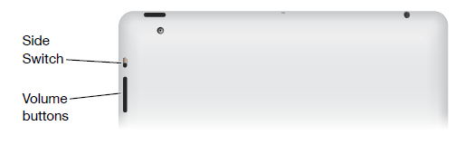

|  |  |
| --- | --- |
| **Increase the volume** | Press the Volume Up button. To set a volume limit for music and other media, in Settings, choose iPod > Volume Limit. |
| **Decrease the volume** | Press the Volume Down button. |
| **Mute the sound** | Press and hold the Volume Down button to mute audio or video playback. |
| **Suppress notifications and sound effects** | Slide the Side Switch down to mute notifications and sound effects. This switch doesn’t mute audio or video playback. See “Sounds” on page 156. |

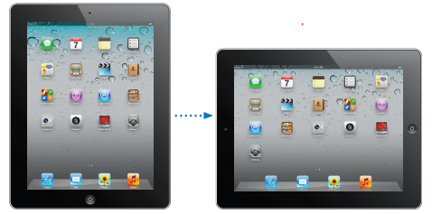

**11) View in Portrait or Landscape**

**12) Lock the screen orientation**

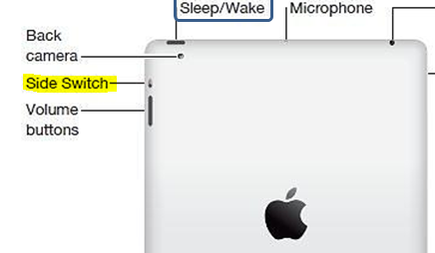

***Settings*** *>* ***General*** *>* ***Lock Orientation OR Mute*** *(use the ‘Side Switch’ to lock)*

You can use the **‘Side Switch’** to lock the screen rotation and prevent the iPad display from switching between portrait and landscape mode.

[](http://www.google.com/imgres?um=1&hl=en&biw=1299&bih=547&tbm=isch&tbnid=uTjtc-Y-WMvrvM:&imgrefurl=http://www.ijailbreak.com/page/31/&docid=8qHvTRjl7P3o9M&imgurl=http://www.ijailbreak.com/wp-content/uploads/2010/10/NoLockScreenIcon-iJailbreak-150x150.png&w=150&h=150&ei=mFMoT5q2PMLgtged_LXpBA&zoom=1)When the orange dot is showing, the current display will lock. When the display is locked the lock icon will appear in the upper right hand corner of the display screen.

**13) Screenshot**

**Take a screenshot of whatever is on the screen:**

Press Home and the sleep/wake button simultaneously.

The screenshot will automatically appear among your photos.

**14)** **Settings**

Tap the *Settings* app to make set your preferences. This is where you will configure your iPad do some basic troubleshooting. The Settings app uses the split screen to display menu items.

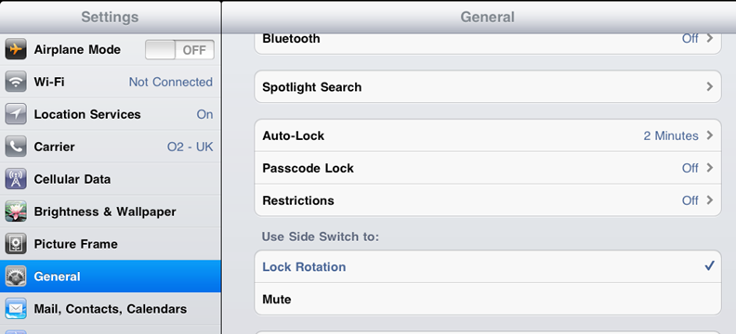

**15) Speak Selection**

Even with VoiceOver turned off, you can have iPad *read aloud any text you can select*.

* Turn on Speak Selection and adjust speaking rate:    
  Go to Settings > General > Accessibility > Speak Selection.

**Have text read to you:**

* Select the text by touching and holding a word
* Drag the selector to include all the text you want read
* Then tap Speak

**16) Free iBooks app**—recommended download from the App Store

--Free iPad 2 Starter Guide by Macworld Editors iPad 2 Starter Guide

Download this book to your iBooks app

--Download PDFs to iBooks

-- There are thousands of free ebooks that can be downloaded to your iPad through the iBooks store

**View the user guide in iBooks:**If you haven’t installed iBooks, open App Store, search for and install “iBooks.” Open iBooks and tap Store.   
Search for “iPad User Guide,” then select and download the user guide.

**17) Connecting to a wireless (Wi-Fi) network**

**Joining a Wi-Fi network**

Wi-Fi settings determine whether iPad uses local Wi-Fi networks to connect to the Internet. When iPad is joined to a Wi-Fi network, the Wi-Fi icon  in the status bar at the top of the screen shows signal strength.   
The more bars you see, the stronger the signal.

Once you join a Wi-Fi network, iPad automatically connects to it whenever the network is in range. If more than one previous used network is in range, iPad joins the one last used.

**Turn Wi-Fi on or off:** Go to Settings > Wi-Fi.

**18)** **Cut, Copy, and Paste**

Once you tap, hold, and release your text, you'll see the following options:   
Select (to select a word) and Select All (to select everything).  
Pick one, and then choose **Cut, Copy, or Paste**, or even choose a replacement word, if you've highlighted a misspelled word. To paste a word, just position your cursor by tapping, then hold down for several seconds until the Cut, Copy, Paste pop-up appears.

**19)** **Using the** **Keyboard**; creating a split keyboard

On iPad, you can type with a split keyboard that’s at the bottom of the screen, or undocked and in the middle of the screen.

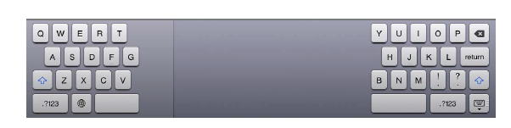

**Turn Split Keyboard on or off:** Go to Settings > General > Keyboard > Split Keyboard, then tap On or Off.

|  |  |
| --- | --- |
| **Use a split keyboard** | Touch and hold the Keyboard key , slide your finger to Split, then release. |
| **Move the keyboard** | Touch and hold , slide your finger to Undock to move the keyboard to the middle of the screen, then release. |
| **Return to a full keyboard** | Touch and hold the **Keyboard key** , slide your finger to Dock and Merge, then release. |
| **Return a full keyboard to the bottom of the screen** | Touch and hold the Keyboard key , slide your finger to Dock, then release. |
| **Turn Split Keyboard on or off** | Go to Settings > General > Keyboard > Split Keyboard, then tap On or Off. |

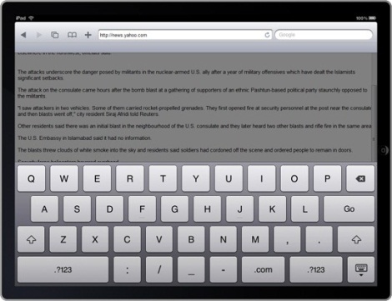

All built-in iPad apps show **a larger onscreen keyboard** when you rotate iPad to **landscape view.**

**Keyboard Key**

**20) Using Safari**

**User Guide**

[Apple iPad 2 Manual and User Guide](http://www.ipad2manual.com/)

* From Safari: Launch your Safari browser from your iPad 2 Tablet, tap on “Bookmarks”, there is a link “iPad User Guide“, Tap on it, it will take you to the iPad 2 User Guide.

**View a webpage:** Tap the address field (in the title bar), type the web address, then tap Go.

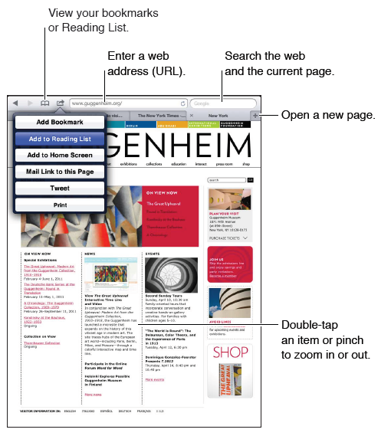You can view webpages in portrait or landscape orientation.

|  |  |
| --- | --- |
| **Erase the text in the address field** | Tap . |
| **Scroll around a webpage** | Drag up, down, or sideways. |
| **Scroll within a frame on a webpage** | Scroll with two fingers inside the frame. |
| **Open a new page** | Tap . You can have up to nine pages open at a time. |
| **Go to another page** | Tap a tab at the top of the page. |
| **Stop a webpage from loading** | Tap in the address field. |
| **Reload a webpage** | Tap in the address field. |
| **Close a page** | Tap on the page’s tab. |

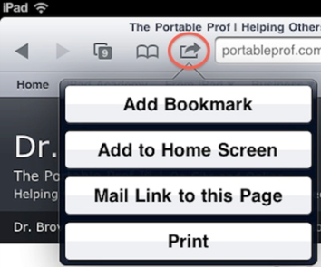**Create a website shortcut on your iPad home screen**

Click the action icon > ‘Add to Home Screen’

**21) Email—Connecting to WISD Outlook email**  
It is recommended that you connect to your **WISD** **Outlook Web email** through the Internet using a program like Safari.

**22) Accessibility Options (see WISD Moodle)**

**23) Taking a photo**

**Emailing a photo**

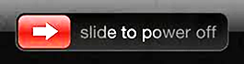**24) Turn iPad off**